**Synthesis of Results for Part 1**

1. ANOVA

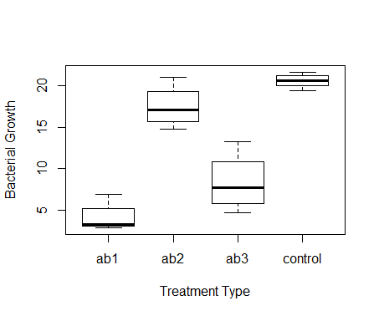

This box and whisker plot visualizes the median growth values for each of the four treatment types. From the median values for each of the four treatment types, the initial guesses for B0, B1,B2, and B3 were selected for the testing of the ANOVA model. The Pearson’s Chi Squared test comparing the null model to the 3-level ANOVA model was run with degrees of freedom of 3 and a test statistic of 37.90132. The p-value was found to be 2.96576 x 10-8, which suggests a high level of significance in the difference between the two models and we can reject our null hypothesis. This means that the antibiotic treatments do significantly alter the bacterial growth.

1. Regression

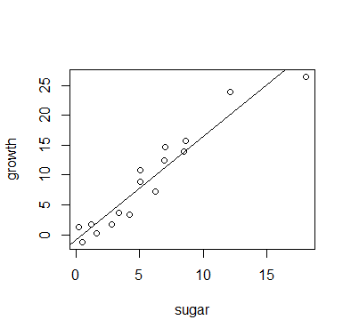

The regression plot shows what appears to be a strong, positive, linear correlation between sugar and growth. A regression model in the form y = B0 + B1*x was created and then compared to simpler model containing only an intercept in order to run a Pearson’s Chi-squared test. This test had 1 degree of freedom, since the complex model (the simple linear equation) contains one more parameter than the simple (intercept-only) model. The test statistic for the model was 39.92512. The p-value obtained from our chi-squared test was 2.638878e-10, which is essentially 0. This p-value means we must reject the null hypothesis that the simple and complex model perform equally well and conclude that the complex model provides a statistically significant better fit of the data.